**Snapshot Life Cycle:**

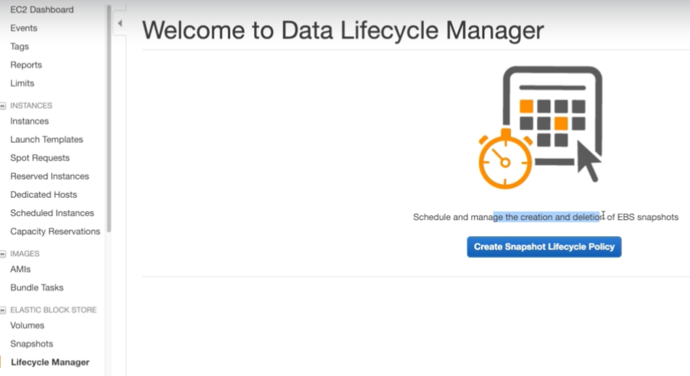

* We can create a snapshot lifecycle to schedule and manage the creation and deletion of EBS snapshots.

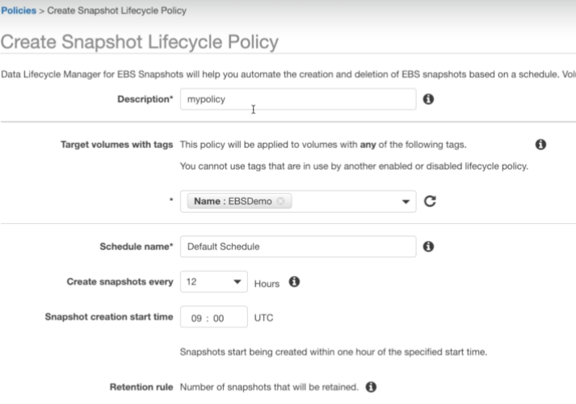

* We can create a policy for the volumes with tags and schedule a tome for that as above.

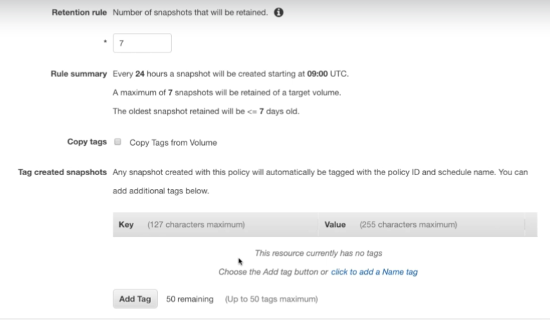

* We need to give the retention time of the snapshots to be cleared. As above it will be cleared after 7 days.
* Then we can copy the same tags from the volume, and we can also add more tags to it.

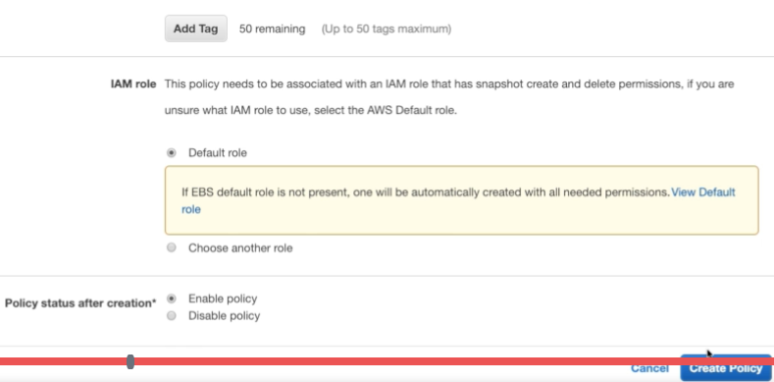

* Add IAM role if needed. Then we can create that policy.